***--------------CI/CD PIPELINE ASSIGNMENT--------------------------------***

1. Create a simple spring boot project with some endpoint.
2. Create a docker file and builspec.yml file.
3. Create a github public repository.
4. Login to AWS And Search for ECR

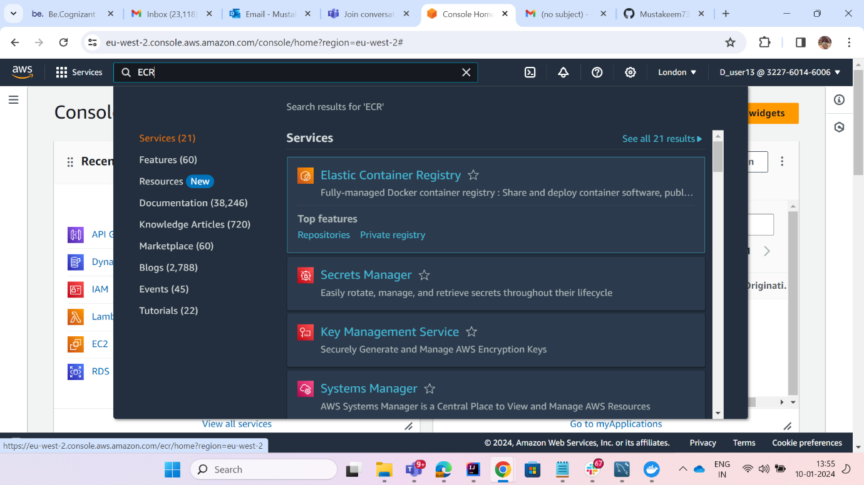

1. Create a ECR a Repsitory.
2. Now Search for CodeBuild

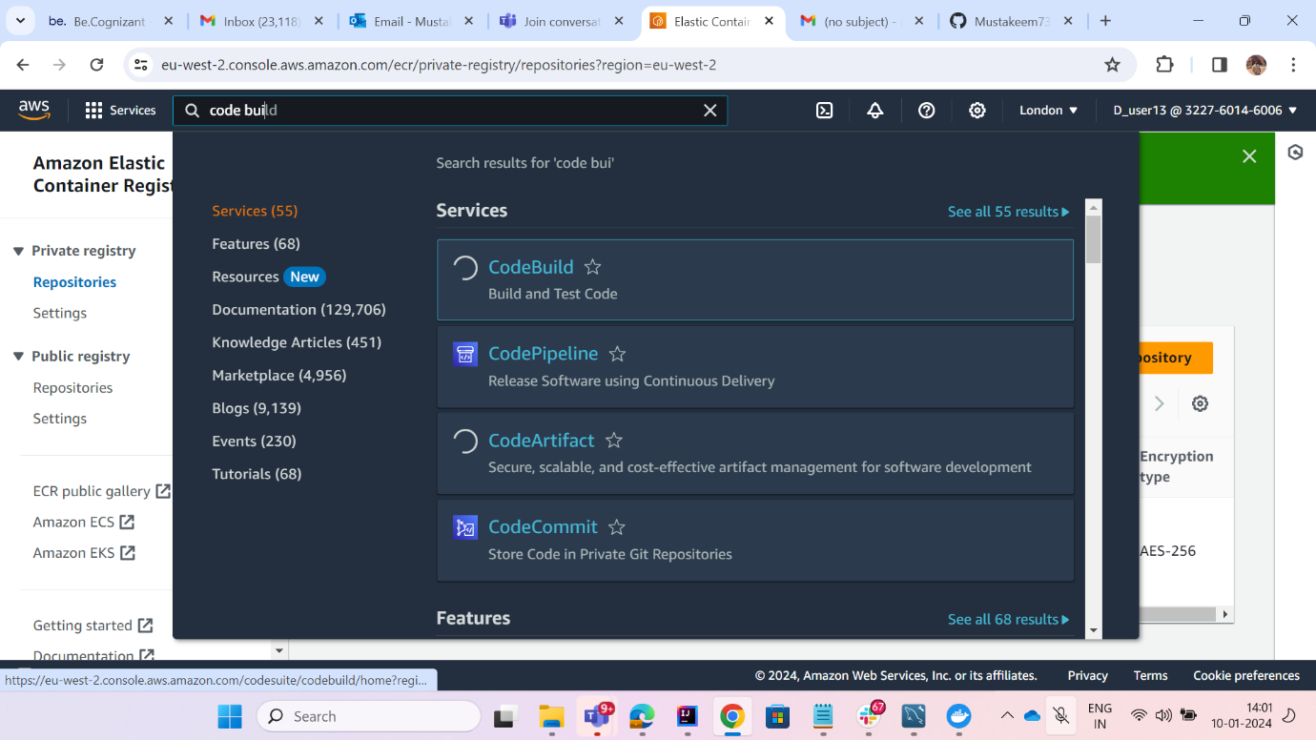

1. Create a Code Build

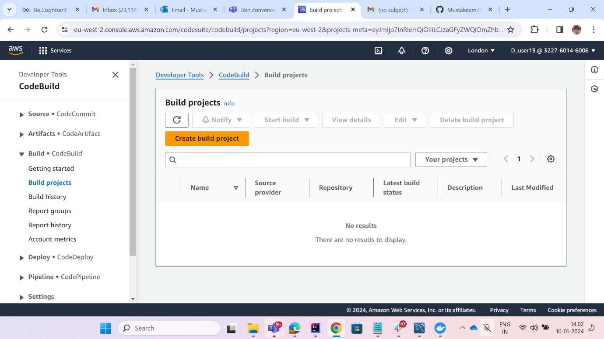

1. Create any name for your code build.

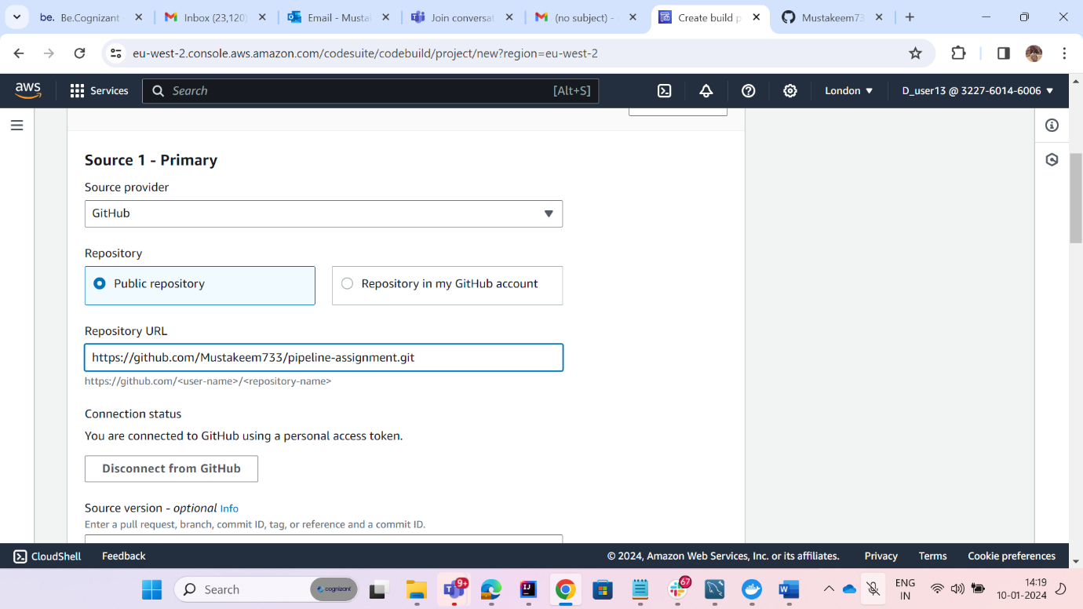

1. Selecte github from Source Provider because our code is in github.
2. Check “Connect with a GitHub personal access token”.
3. Provide the github personal token which you will get from your github account.

* Go to setting -> Developer Setting -> Personal access token ->
* Tokens(classic) -> Create a new token -> give name ->
* Check repo, write:packages, delete:packages
* Generate Token

1. Paste the token in Code Build -> Github personal token and save token
2. Provide the github url of your project.
3. Now in Environment select operating system as Amazon linux and Runtimes as standard and image -> 5.0

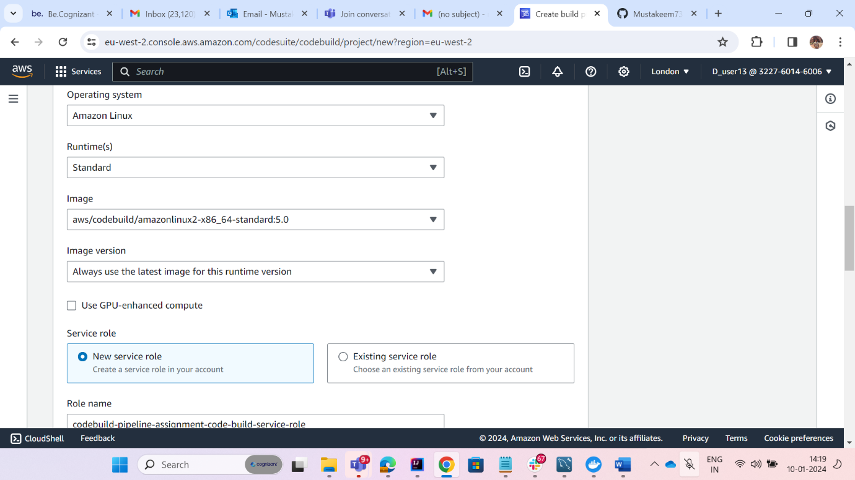

1. Form additional configuration check priviledged.

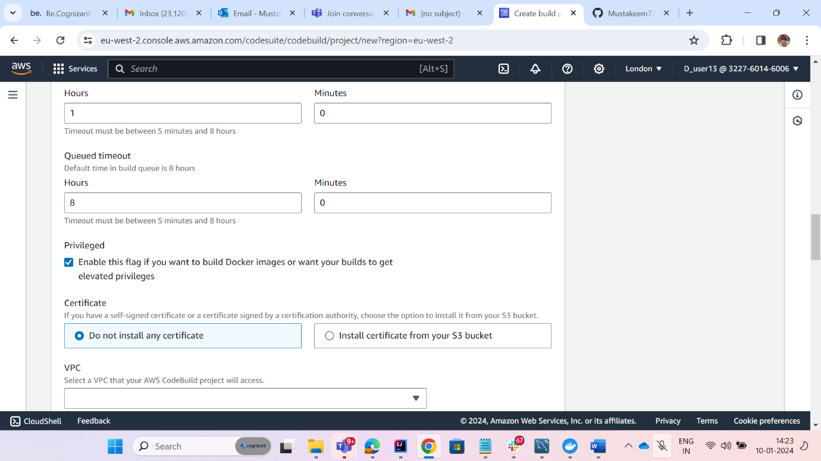

1. Create the Code Build.

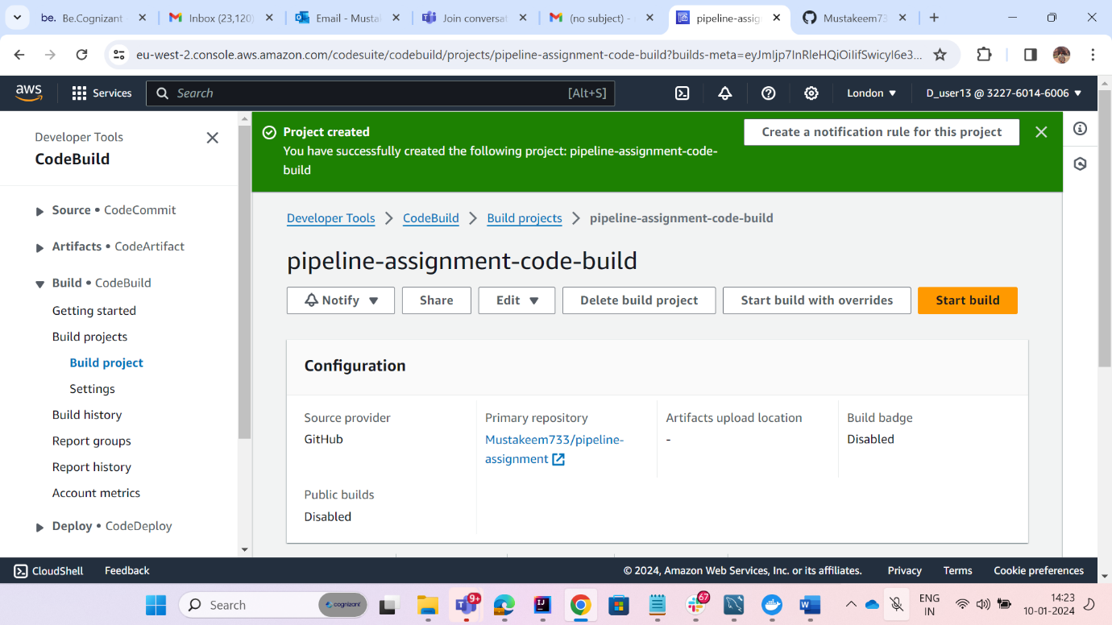

1. Now Naviate to you ECR and in open your repo and click on view push commands

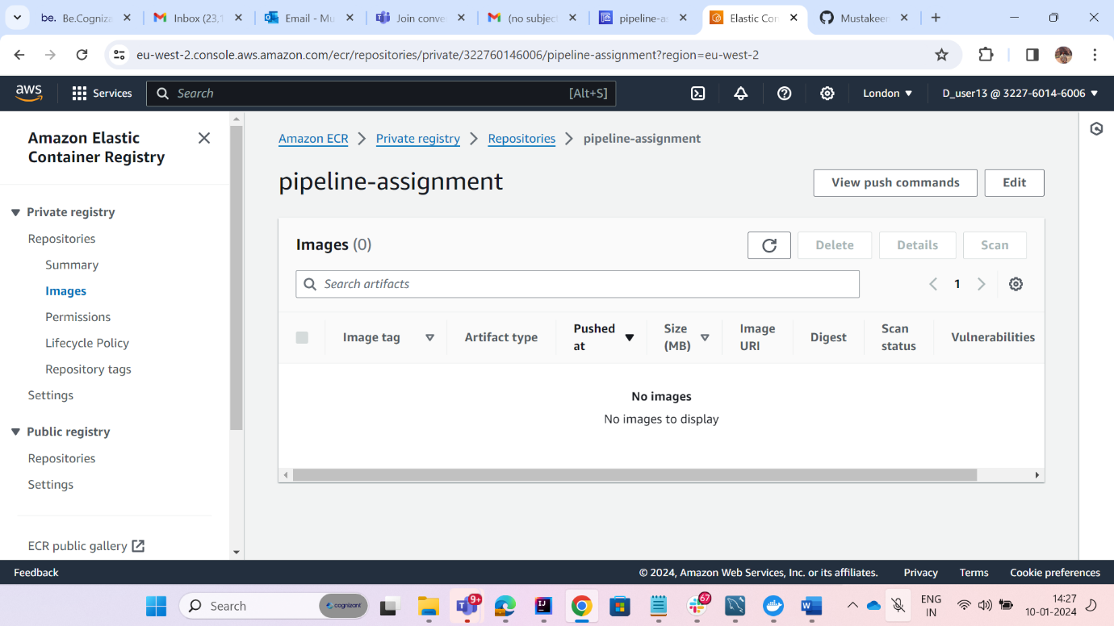

1. Copy the command and paste it in buildspec.yml -> pre build:commands

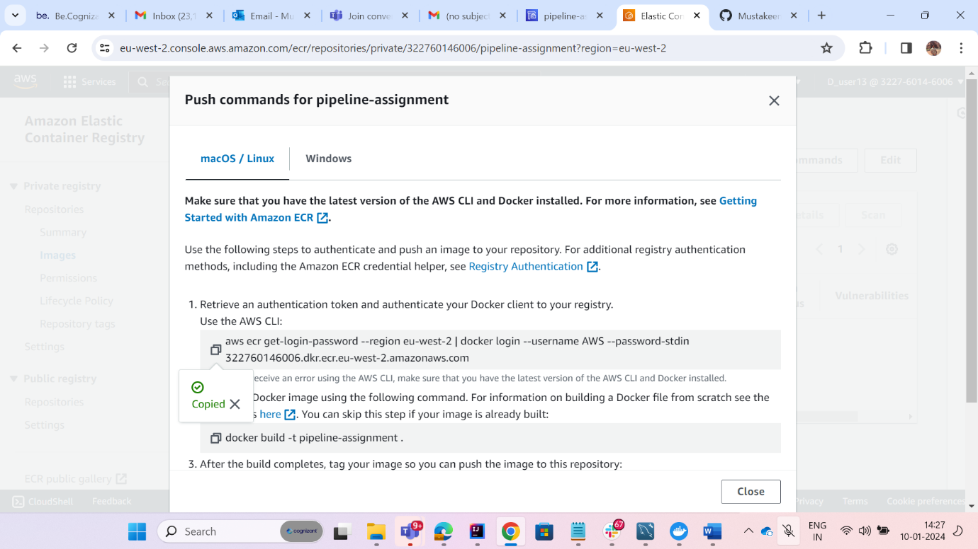

1. Copy the Repo Url and paste it in buildspec-> pre build: REPOSITORY_URI

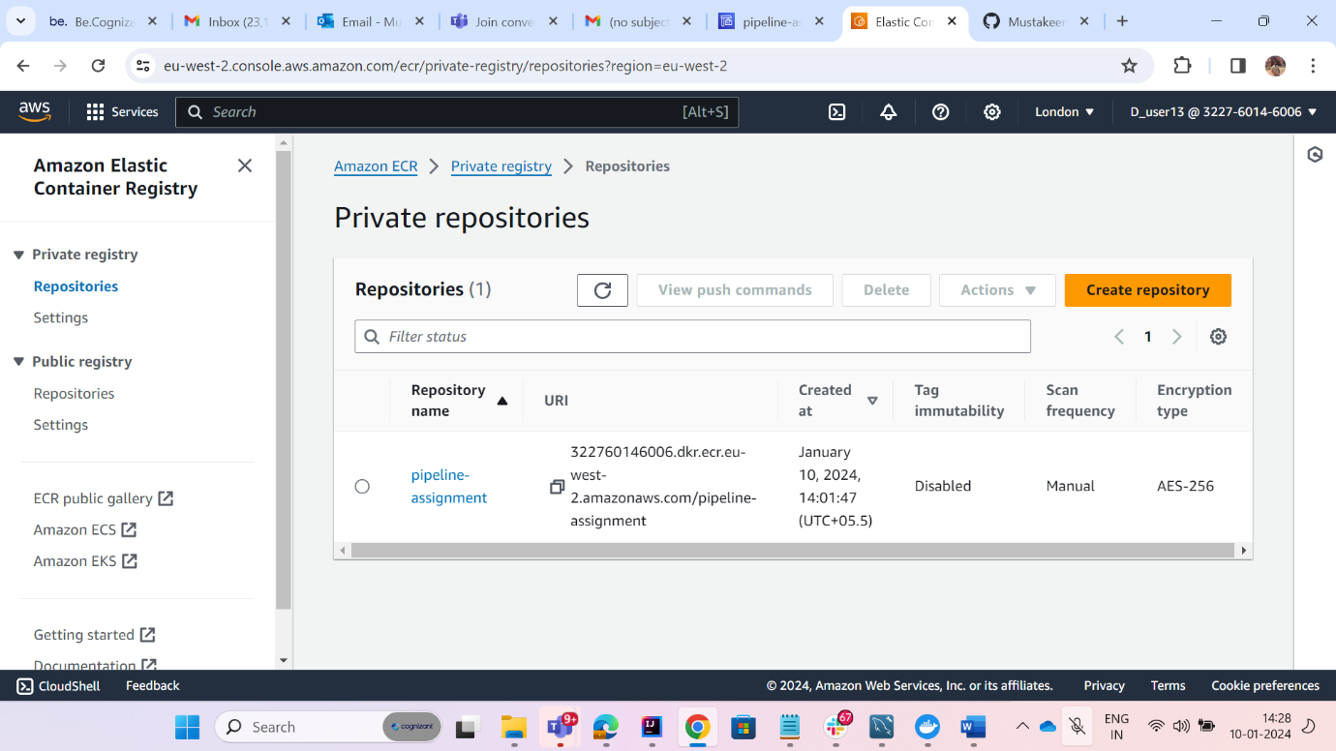

1. Push the update code to github.
2. Now Navigate to IAM -> Roles and search for the role which created by code build.

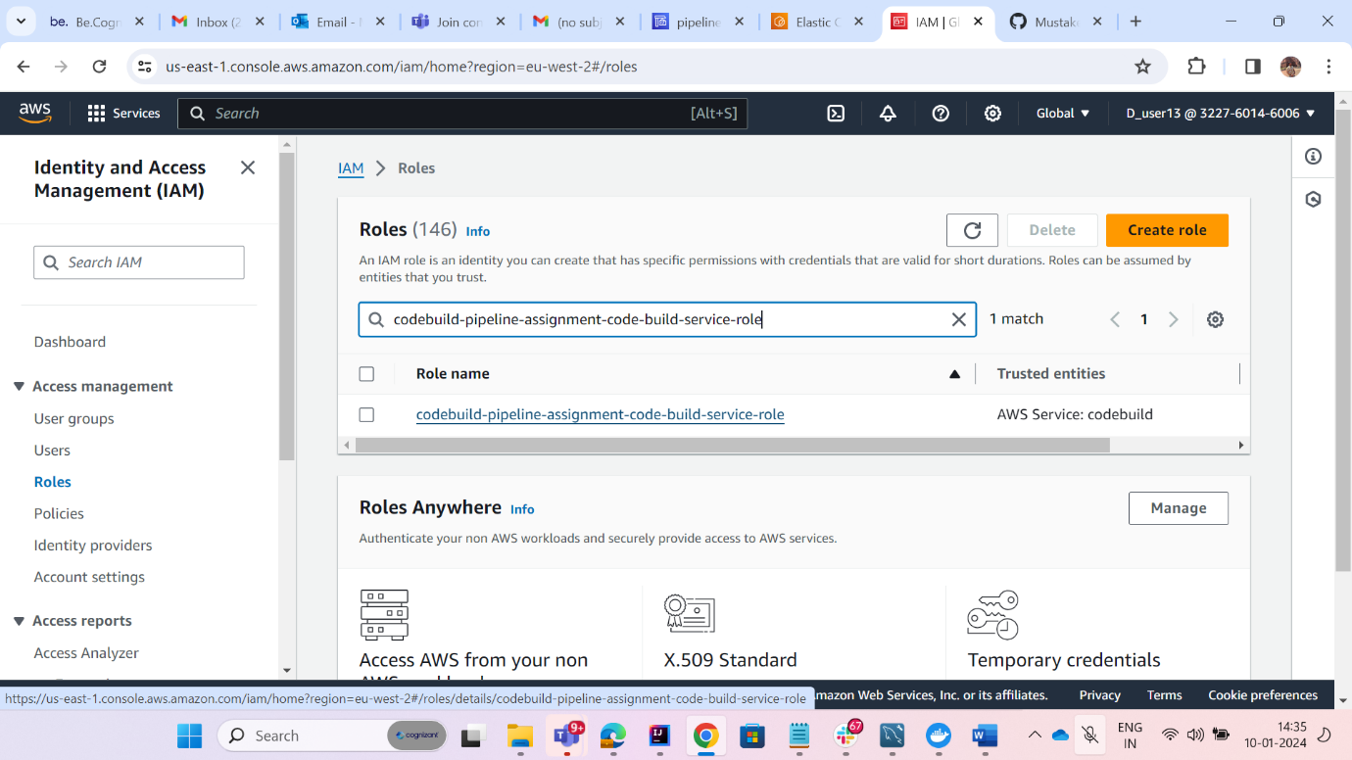

1. Now give the necessary permissions.

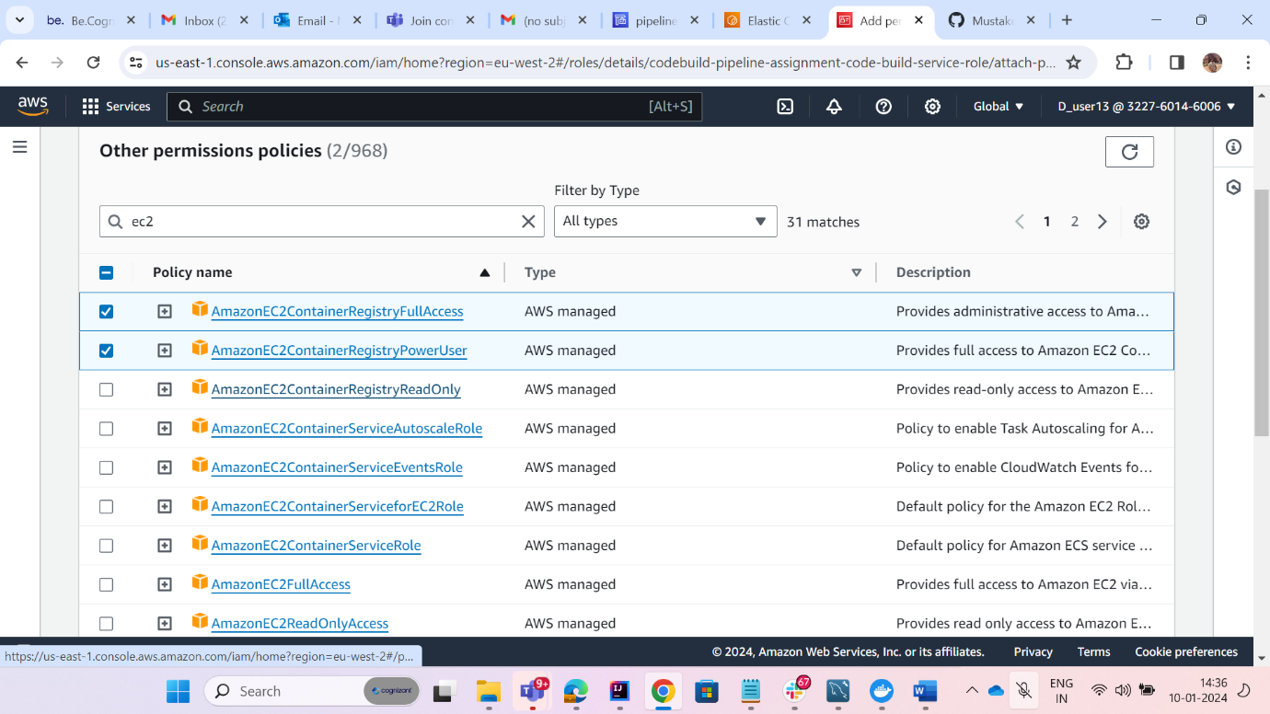

1. Now go to your code build and click on start build.

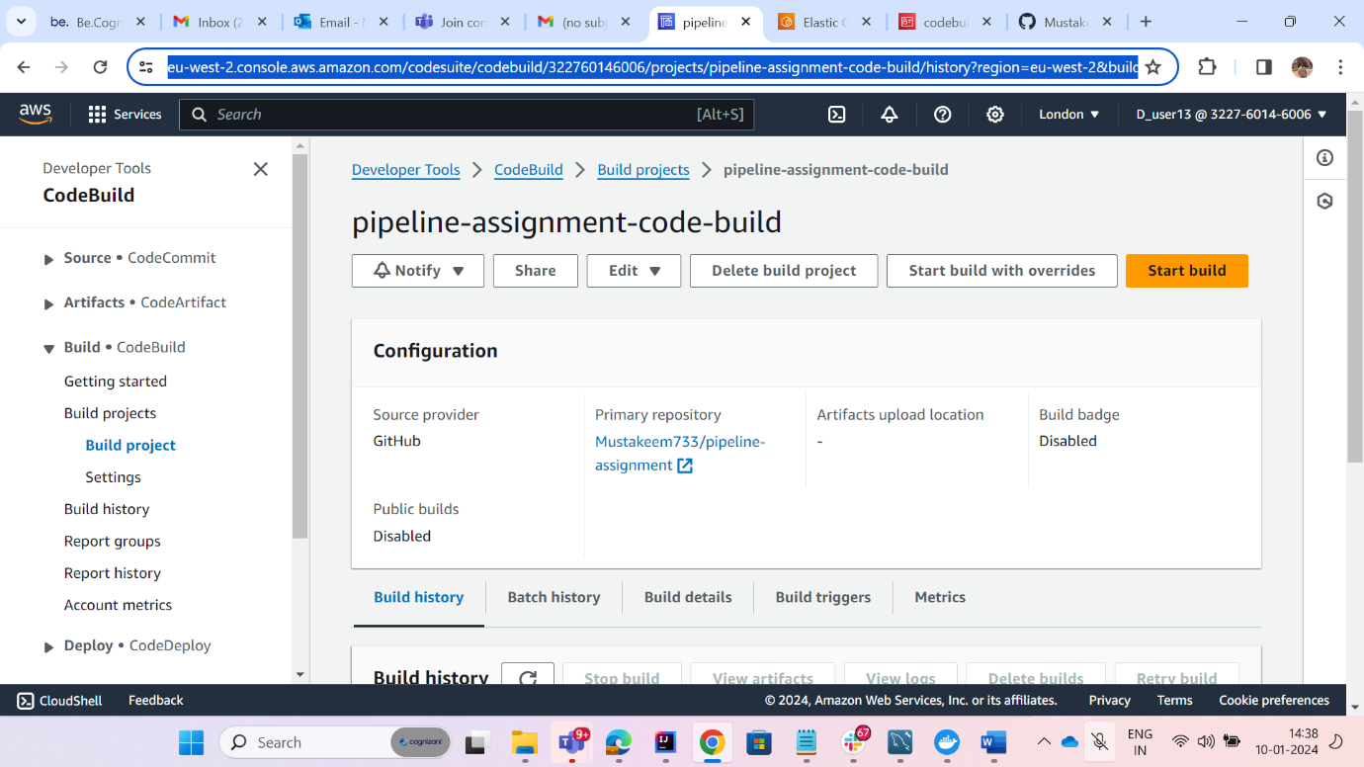

1. Now will see all phases have started successfully.

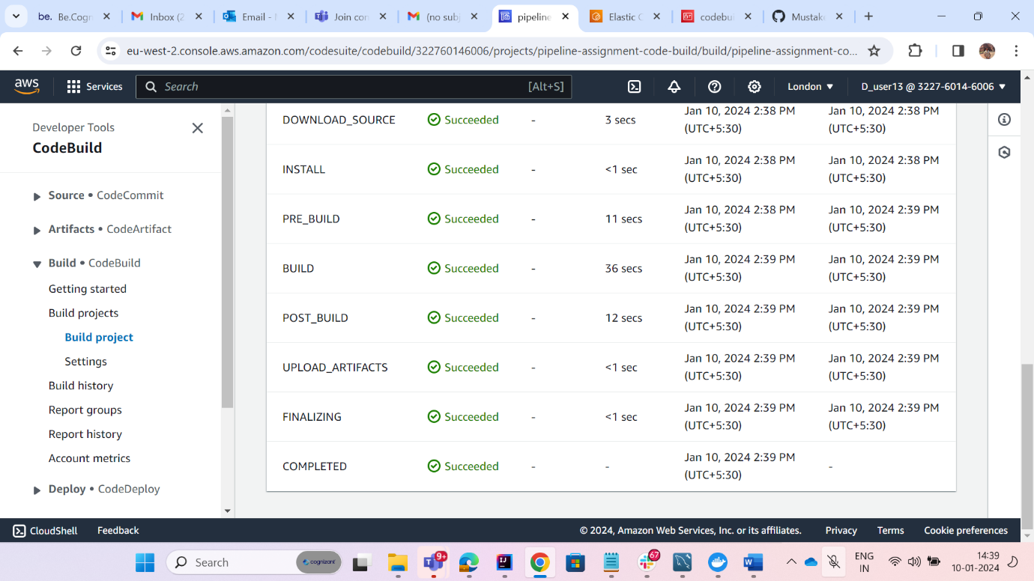

1. Now Navigate to your ECR Registry and a image would be created there.

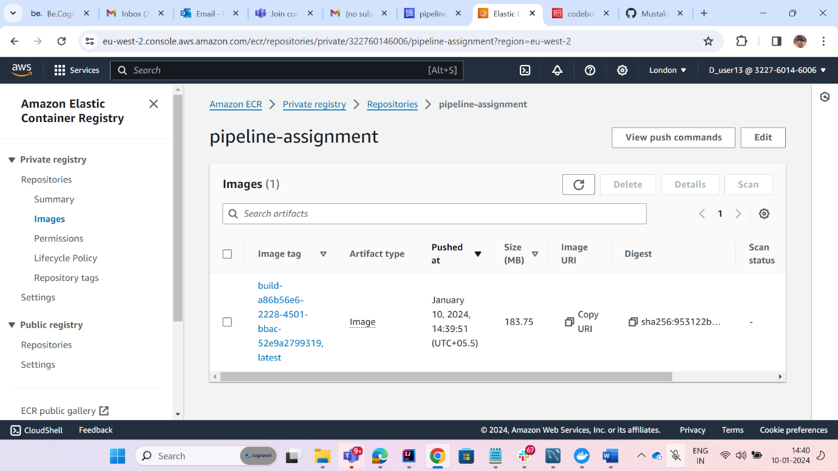

1. Now Navigate To ECS and create cluster.

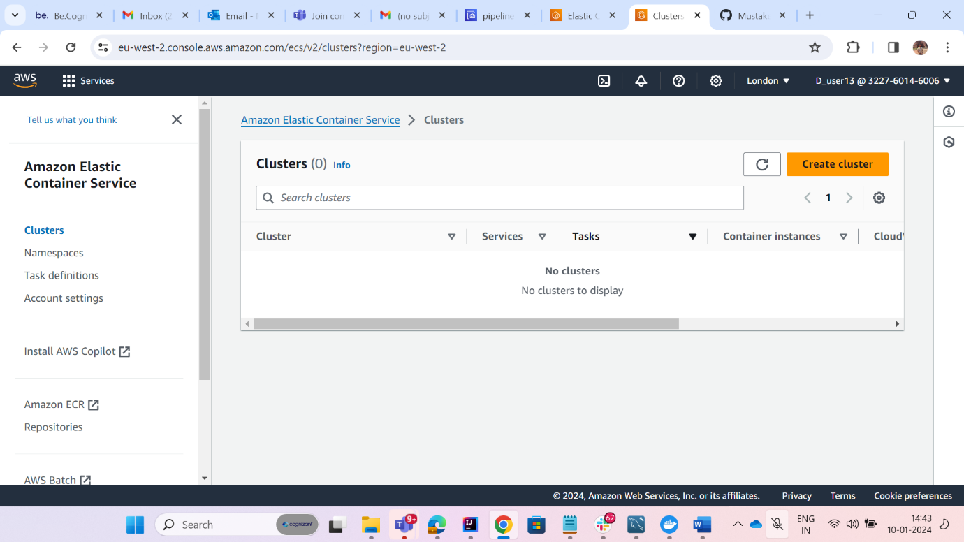

1. Give Cluster name and check AWS fargate and create cluster .

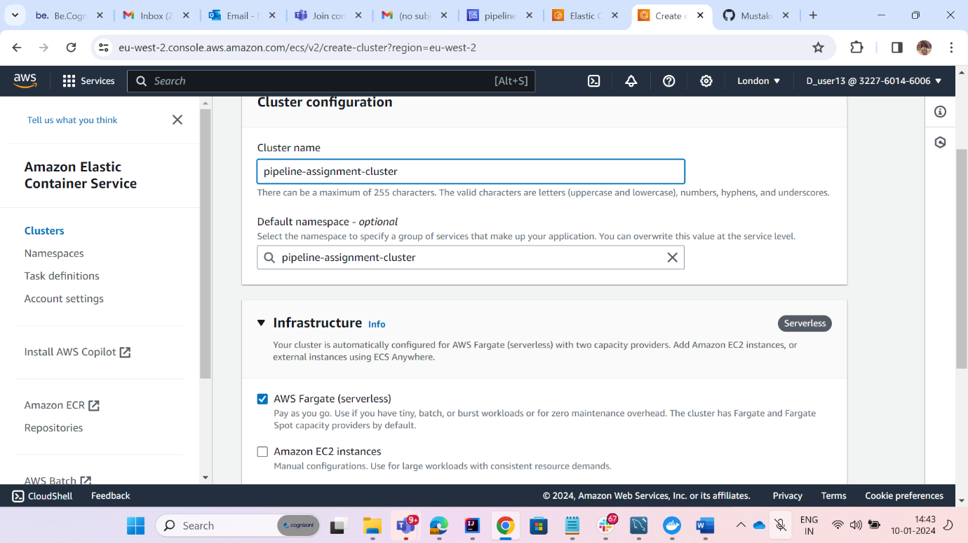

1. Now We need to create task definition

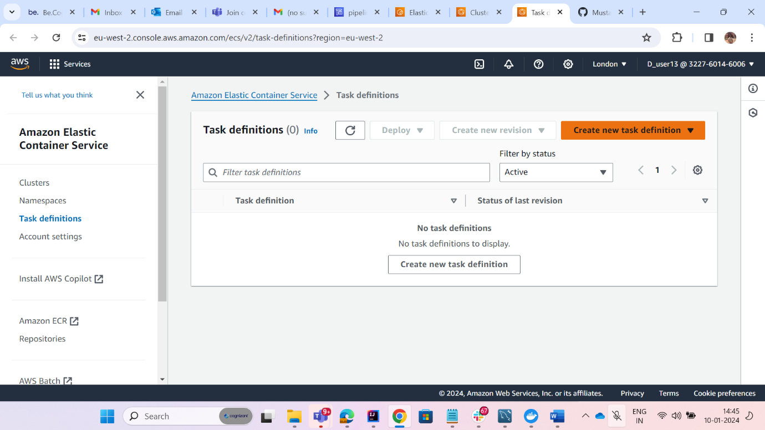

1. Give name to your task definition and select Aws fargate and select create new role in task execution role.

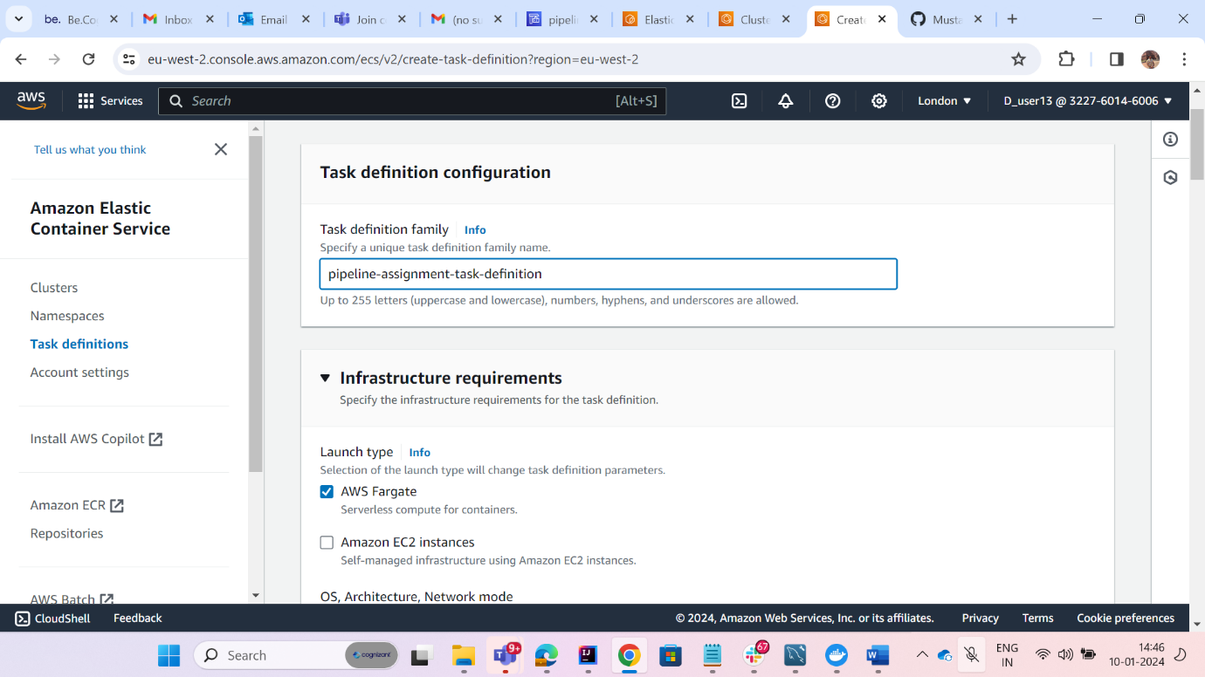

1. Now in Container give container name which you have given in your buildspec.yml file and give image url from ECR URI.
2. Allow container port on which application will run and port name as conatainername-80.

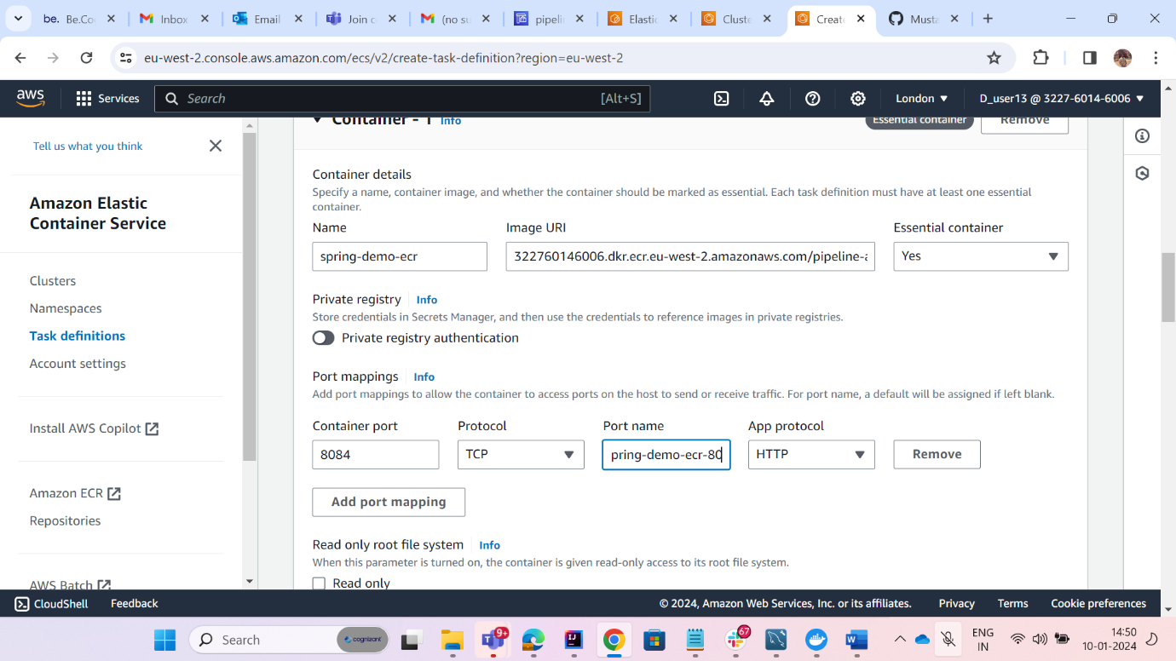

1. In Health check give the command for actuator health.

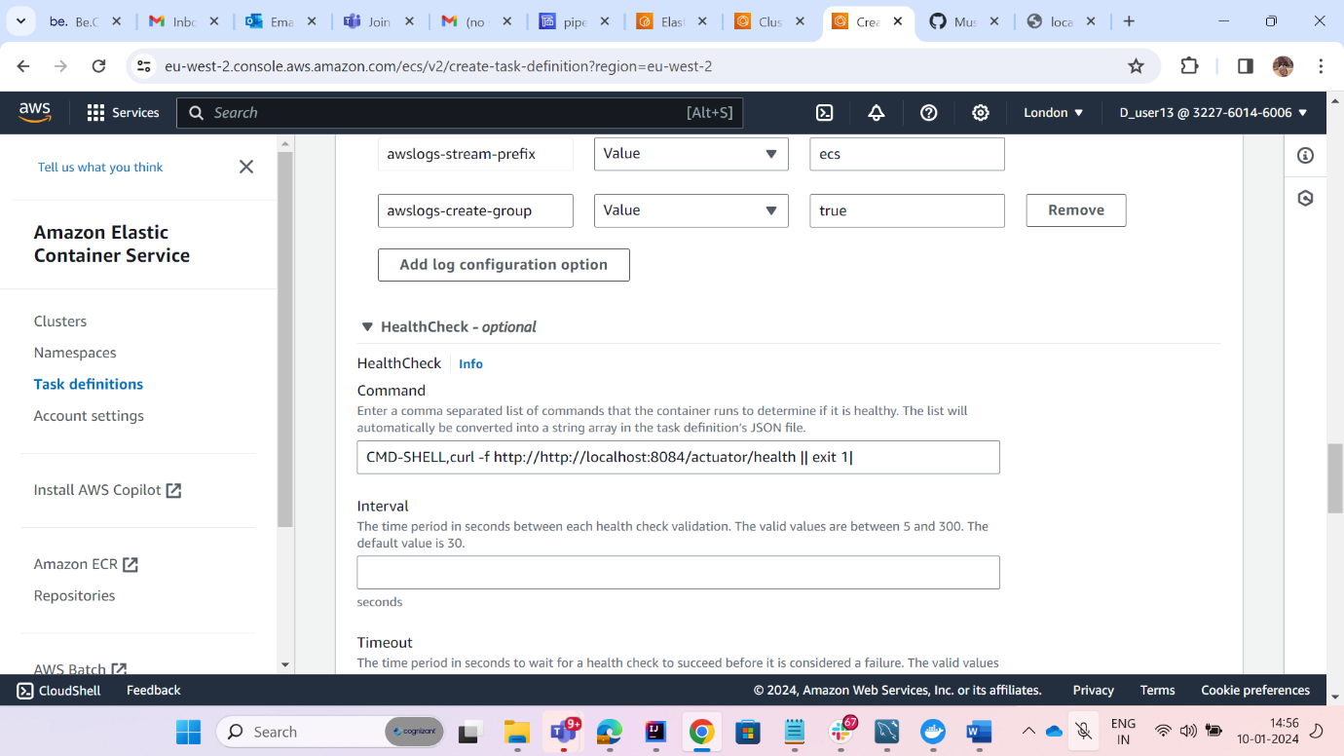

1. Create the task.
2. Navigate to your cluster and open it and go to services and create a service.

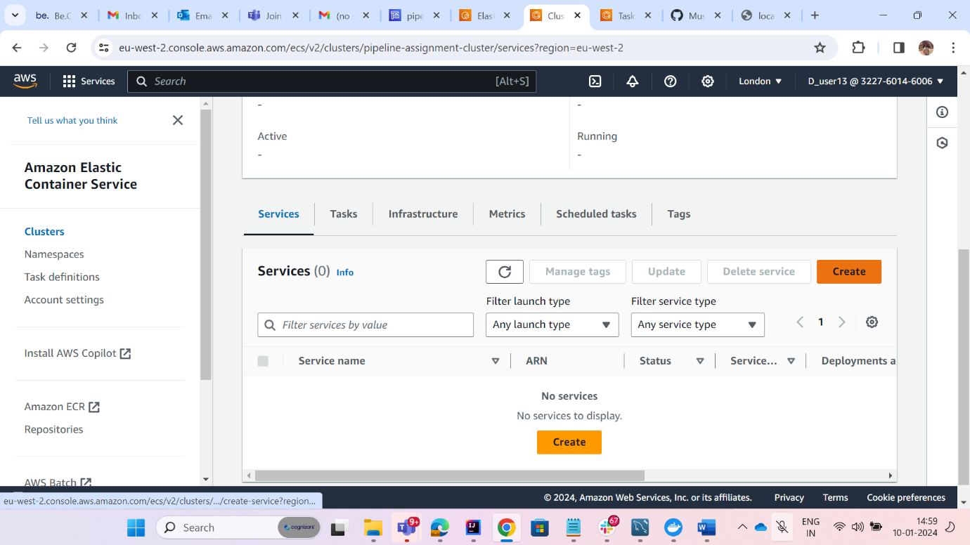

1. In services check on Launch Type from Compute options.
2. In Deployment Configuration in Family select the task you have created and a name in service name.

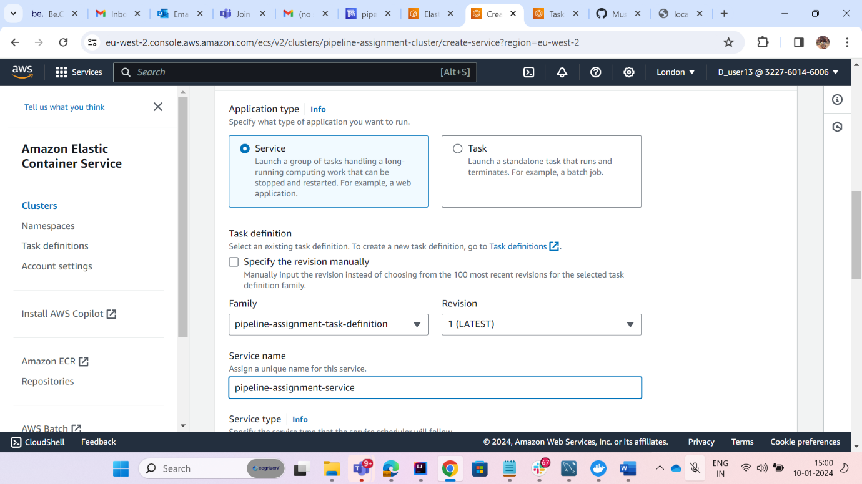

1. Create the service.
2. Now Navigate to task -> Configuration -> enid -> security groups and allow necessary ports.
3. Now check for public address from task -> configuration -> public Ip and use the url with port number and endpoint is it working fine or not.

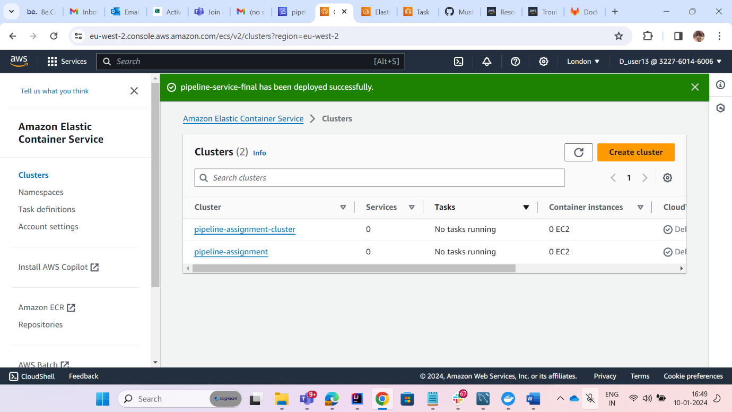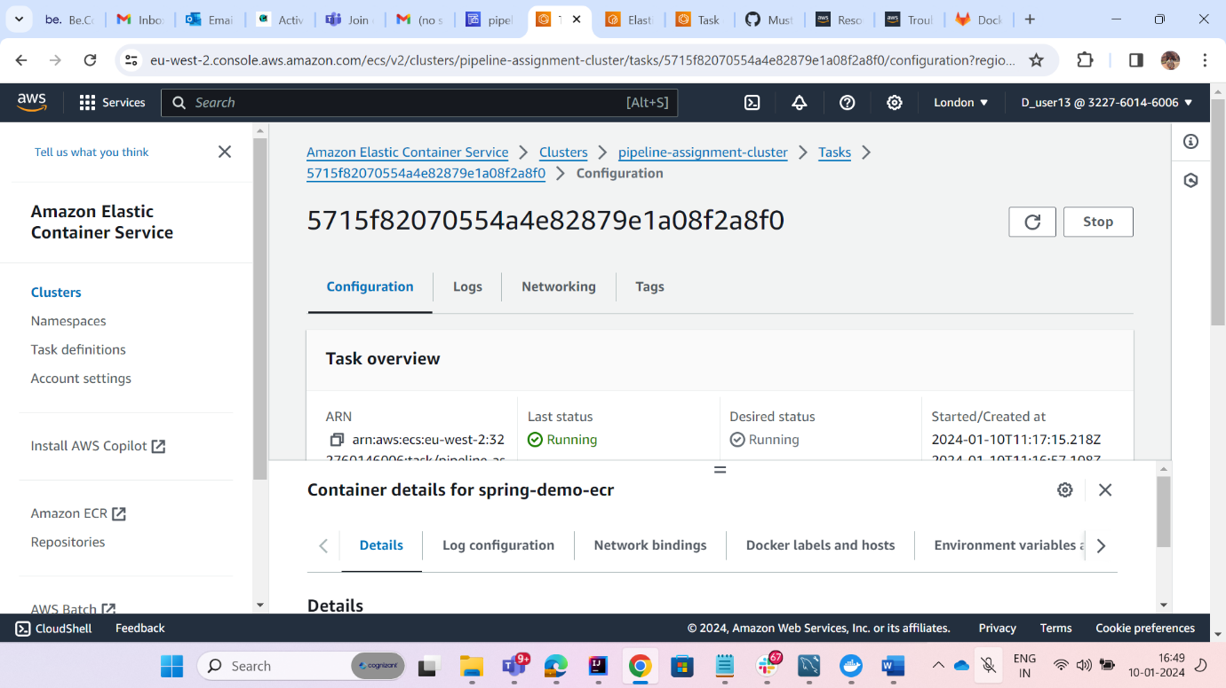

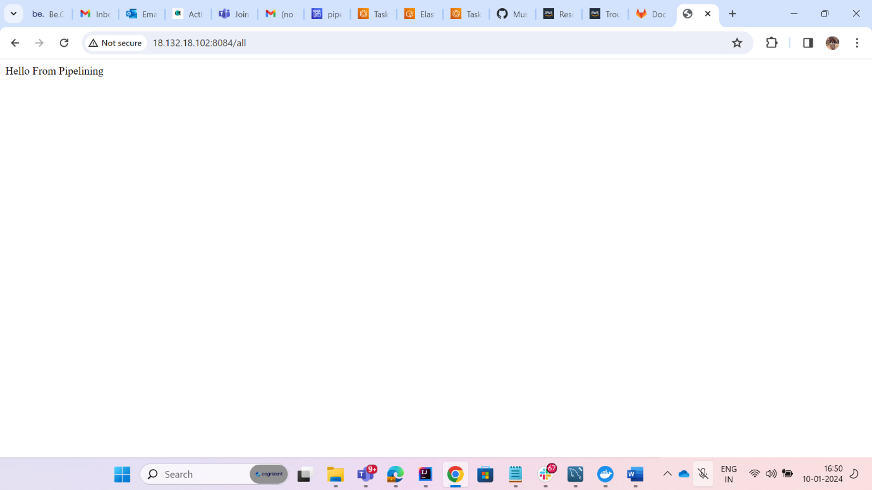

1. Now Create a pipeline . Go to Code pipeline from Aws management Console.

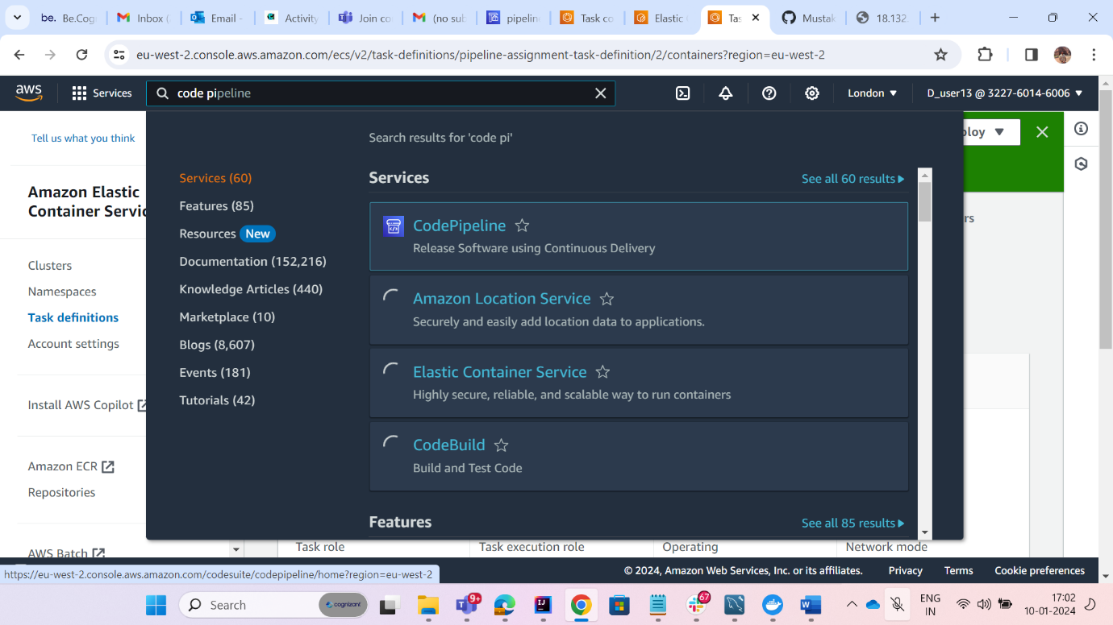

1. Click on create pipeline.

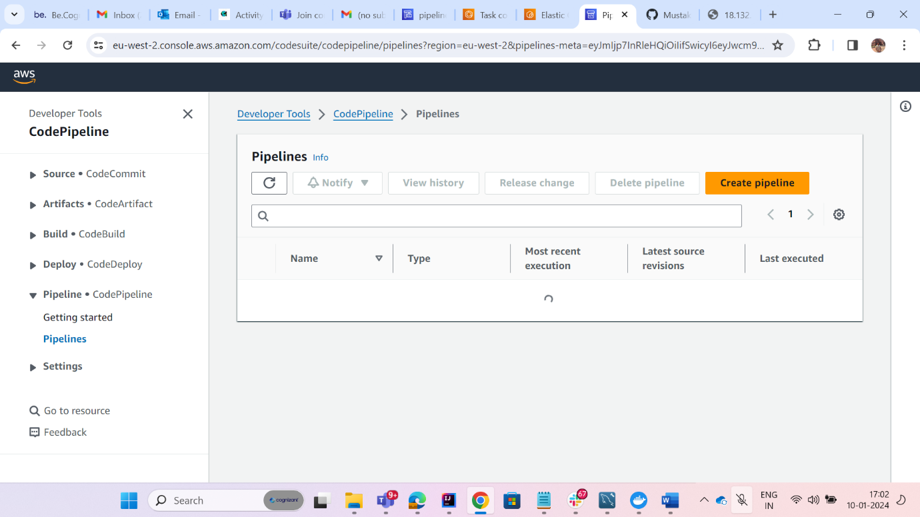

1. In First page just give the name and click on next.
2. On second page select github version 2 and then click on connect to github.

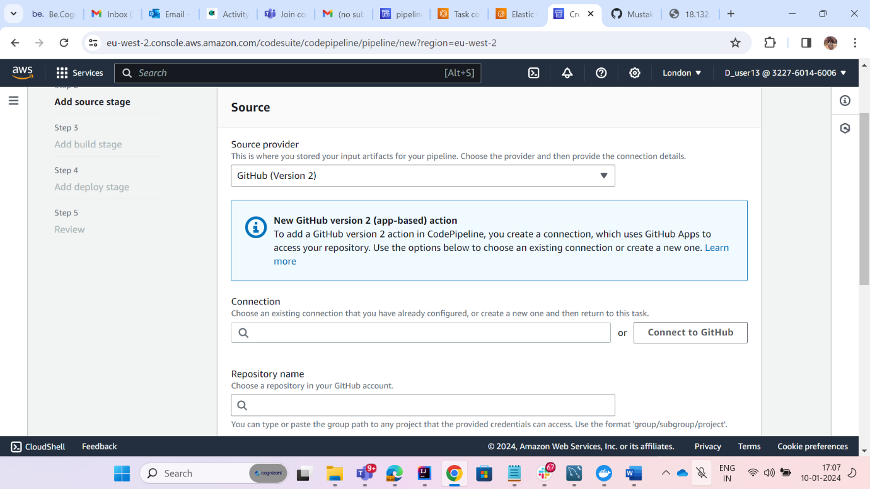

1. Then connect with github and click on install a new app.
2. Then configure with github and select the repository which you are deploying. And the click on connect.

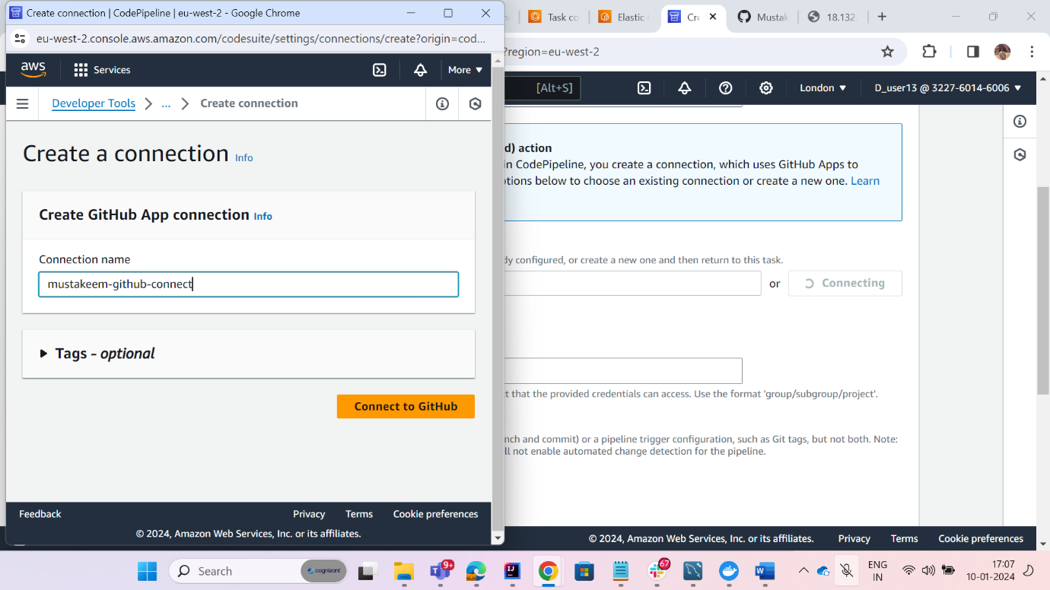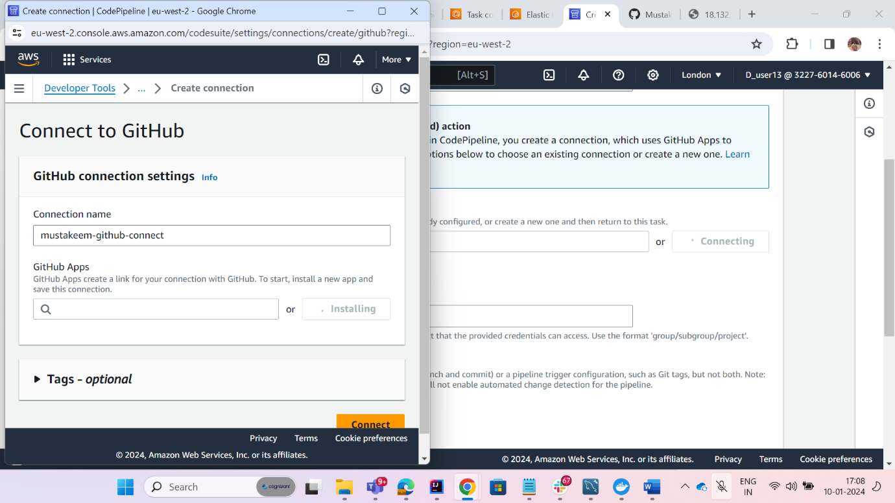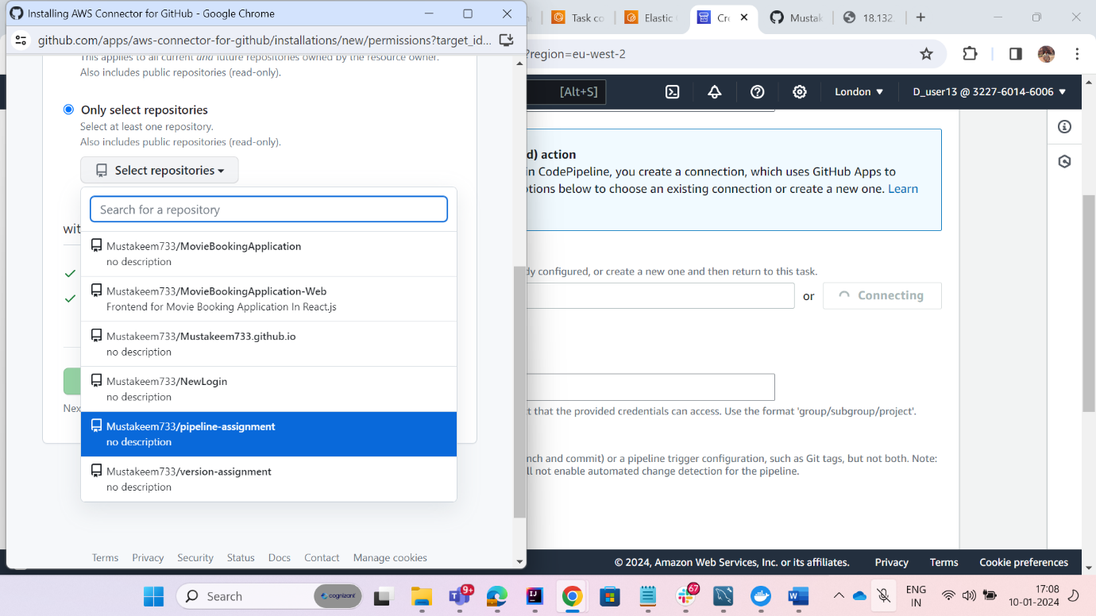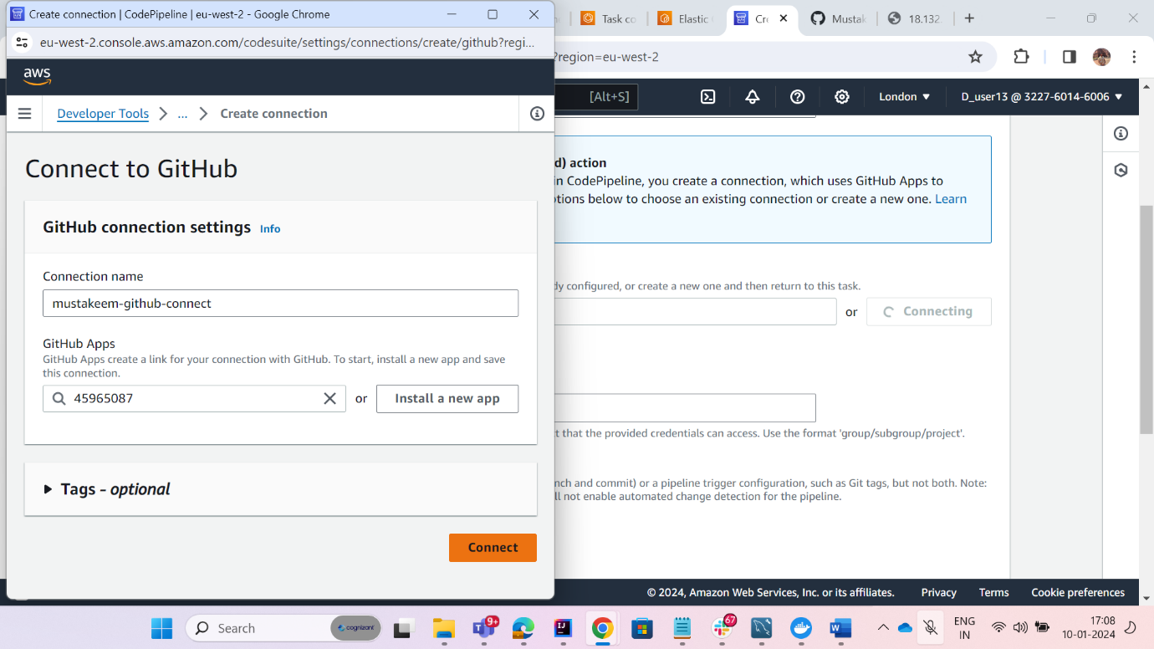

1. Then there will be a option of Repository name in that select your repository.

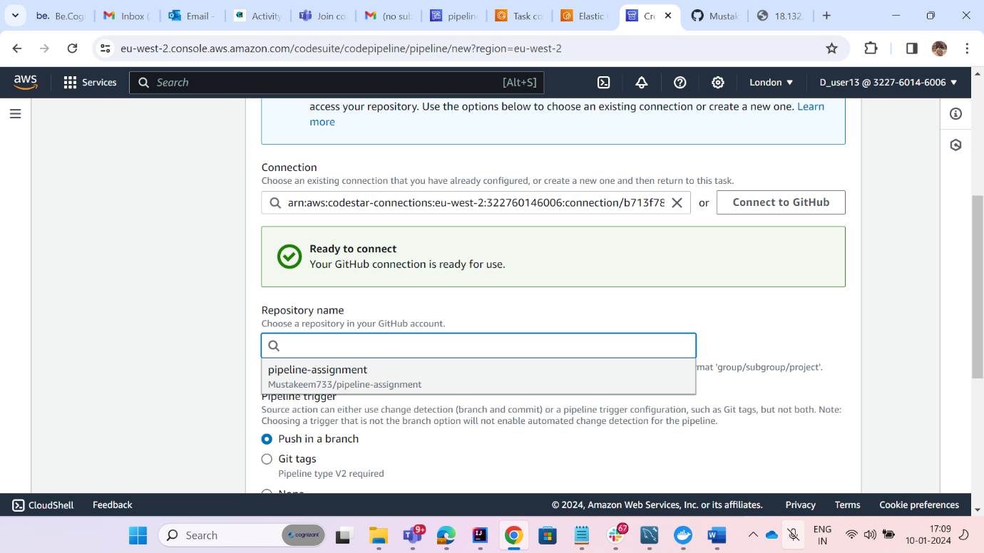

1. Select the branch and click on next.
2. In Build provider select AWS Cod build and from project name select your repository and click on next.

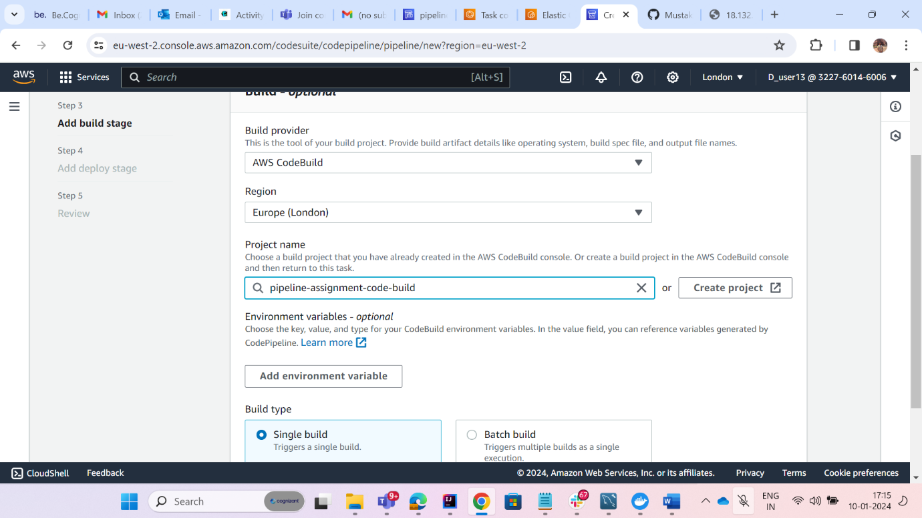

1. Select Amazon ECS in deploy provider and then select your cluster and service and click on next.

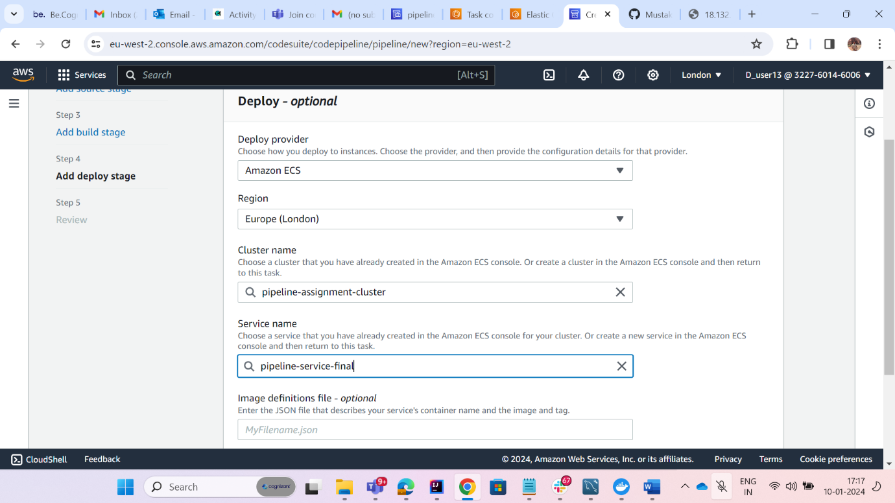

1. Review everything and create pipeline.

***-----You have successfully created the aws code pipeline and intefgrated CI/CD---------------***

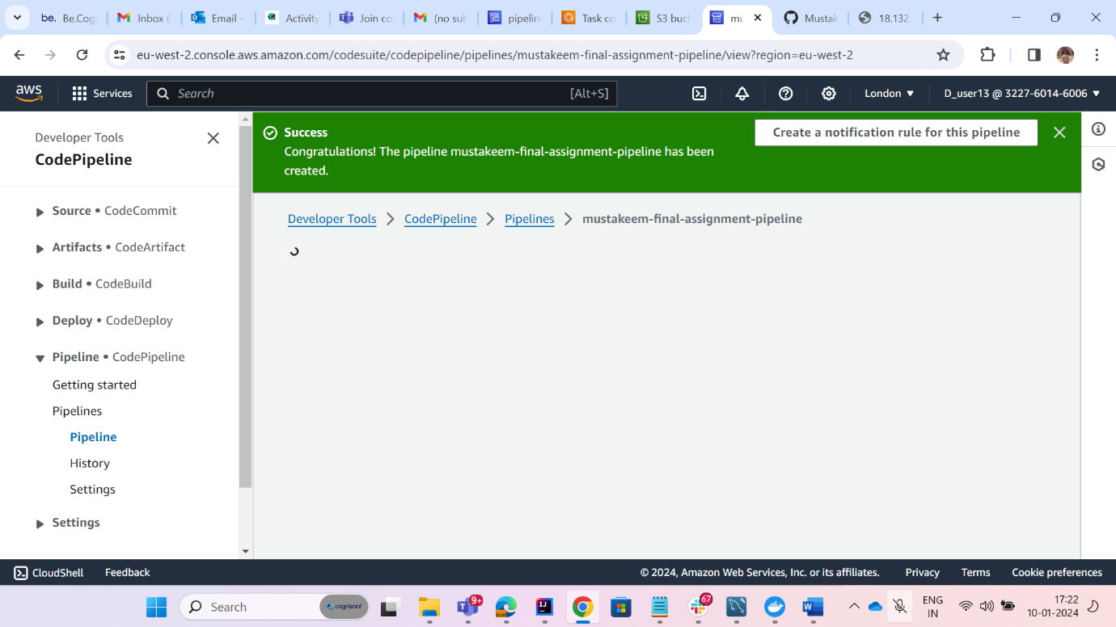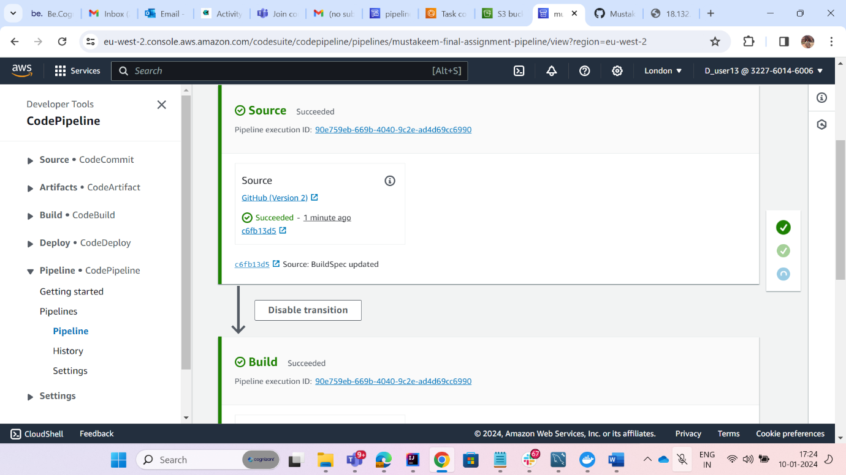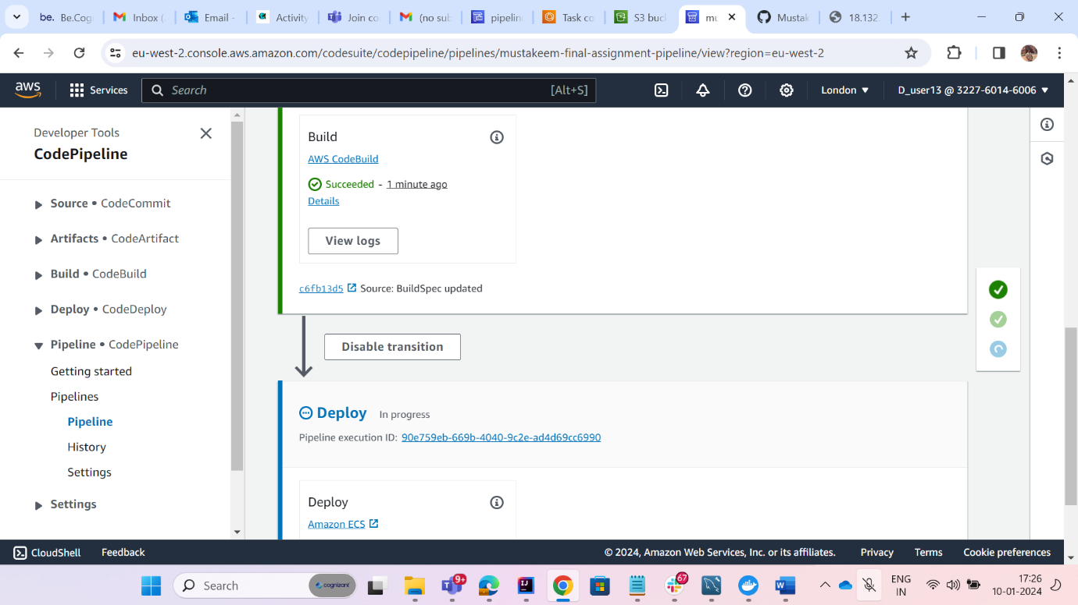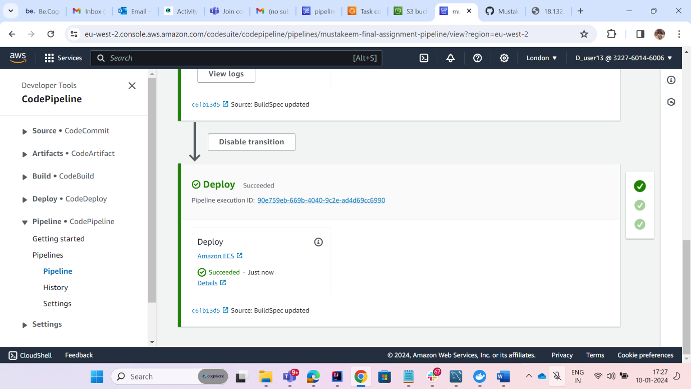

***Now Let us Make some changers and push the code in github and check if its CI/CD working fine or not .***

1.I have added one more endpoint which is returning “Hello from CI/CD pipeline”

2. Now I will push the code to github and pipeline will start again and push the code to the profuction.

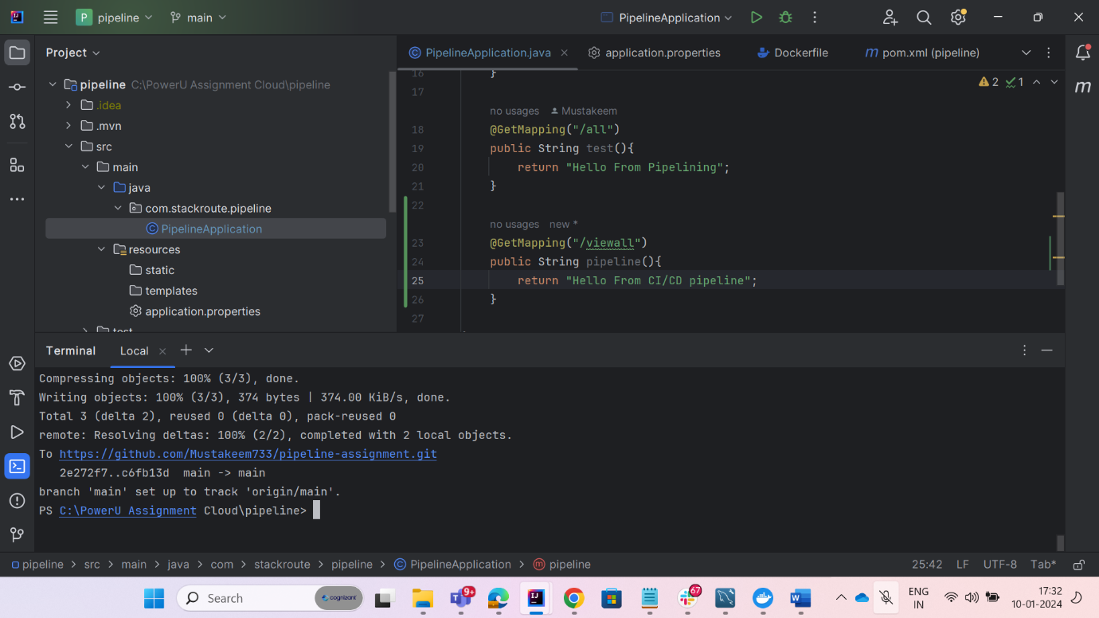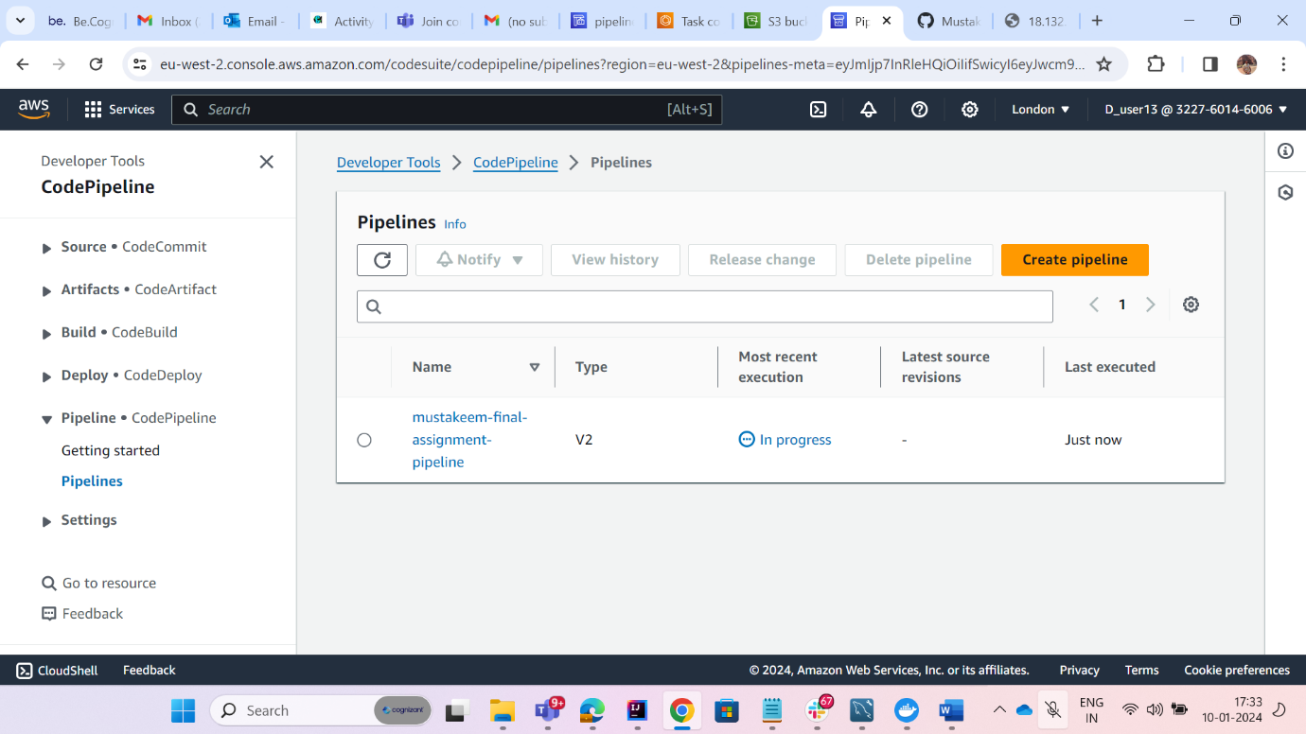

This is final result after committing changes.

